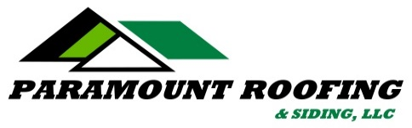

AWARDED 2015 SUPER SERVICE AWARD
With an overall “A” Rating

Awarded to the top 3% of contractors nationwide.

REVIEW:

Shannon H.
1102 Wxxxx xxx  Madison, WI 53711  Categories:  Roofing, Chimney Repair  Services Performed: Yes  Work Completed Date: March 16, 2015  Hire Again: Yes  Approximate Cost: $12000  Home Build Year: 1964  Description Of Work: Paramount did a tear off of our old shingles, replaced approximately six rotten plywood boards and re-roofed our home. They re-flashed the chimney, installed two Broan vents and worked around skylights.  Member Comments: We are extremely happy with Paramount. Mike came out to do our estimate which they provided that same day. They were installing the roof within two weeks time. Their foreman was very helpful and answered all of my questions. The team worked hard and completed the entire job in one day as promised. Our roof looks wonderful. Their price quote was very fair. We highly recommend Paramount and would use them in the future. | Overall A  Price A  Quality A  Responsiveness A  Punctuality A  Professionalism A

